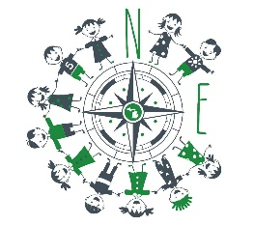
Northern Explorers Waitlist
Childs Name | Childs DOB

Desired Start Date:
Rosters are re-evaluated 3x per year. If you would like to start in the middle of a trimester you will need to request the month that covers that date. To save the spot you will be required to pay for the weeks not attended that lead up to your start date.

Start Date | Full Or Part Time | Preferred Drop off/Pick Up Time | Payment Method
- January  - June  - September  - First Available | - Full (M-F)  - Part (T,W,TH)  - First Available |  | - DHHS  - Tri-Share  - Private

Parents Contact Information:
Name:______________________________________
Phone:______________________________________
Email:________________________________________
Email is our preferred method of communication so we can look back and reference information if needed.
What you can expect next:
You will be contacted via email if a spot opens up to verify you are still interested with required enrollment paperwork attached to the email. You will have one week to complete the required paperwork and return it with a one month, non refundable deposit to hold your child’s spot. The deposit will need to be money order or cashier’s check.

